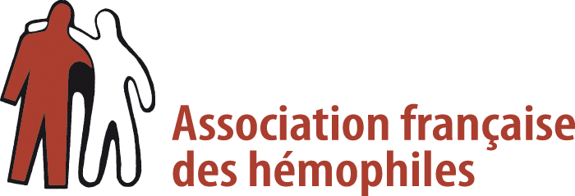 

**In 2021, the French Hemophilia Association (AFH) is launching a call « Henri Chaigneau » for proposals aimed at supporting research into the management of haemophiliac arthropathies**

The treatment of haemophilia, a constitutional coagulation disorder, has made considerable progress in recent years.

Nevertheless, one of the main consequences of this pathology, recurrent bleeding in the joints, leads to a deterioration of the cartilage, called "haemophilic arthropathy" which is one of the most debilitating consequences of haemophilia. It leads to sometimes severe handicaps, even in young subjects. It is characterised by progressive complete destruction of the joint concerned with permanent pain, locomotor disability and poor quality of life. The treatments available are essentially symptomatic or preventive to limit bleeding and consist of the injection of coagulation factors. It is therefore important to develop new therapeutic approaches to improve the condition of the joints in these patients.

This call for proposals aims to cover all fields of research in the study of cartilage.

It aims to support an innovative project on new fundamental, preclinical or clinical research strategies to prevent, preserve or repair cartilage degradation in patients with bleeding disorder.

The programme should enable progress to be made in the assessment of the articular state of patients, on the mechanisms leading to the degradation of cartilage and their prevention. It may also focus on innovative studies aimed at repairing damaged joints. The fields considered will include the fundamental aspects (molecular mechanism) of this arthropathy, in animal models or in humans, as well as clinical research, the foreseeable health applications of which will have to be specified.

Projects concerning the search for new therapeutic pathways, in particular regenerative medicine and/or cell engineering will be particularly encouraged. Research and clinical trials are currently underway in the treatment of osteoarthritis. The projects submitted should show how these new techniques could be applied to haemophilic arthropathy.

Applications that meet all or part of these criteria may be considered.

In all cases, the projects must clearly set out the expected impact and benefits for the patient.

Two types of projects may be funded: advanced projects with preliminary data or "pilot" projects dedicated to early stage but large-scale research.

The project leader should present the amount of financial support requested within a provisional budget identifying human and material resources required. The amount allocated will be determined according to the budget available at the AFH.

Depending on the project(s) selected and the results obtained, AFH financial support, through itsEndowment Fund for research on hemophilia (FRH, Fonds de dotation de Recherche sur l’Hémophilie) and/or its Hemophilia Association Funds hosted by the Fondation de France, may be renewed annually, once or several times, or readjusted by the AFH Board of Directors (CA). The amount of this future support has not yet been defined and will depend on the donations collected by the association at the renewal deadlines.

Applicants must submit to the AFH a complete and detailed file, written in English to enable assessment by international experts, indicating:

* Presentation of the project
* Presentation of the Project leader
* Project summaries in English and French
* Description of the research project
* Information about the project team
* Provisional budget and funding already secured
* Administrative information about the project structure

The application form can be downloaded from the AFH website:

<https://afh.asso.fr/wp-content/uploads/2021/03/Application-File.docx>

The deadline for submitting applications is **June 1st 2021**.

Applications must be sent by e-mail to the following address: [genevieve.pietu@afh.asso.fr](mailto:genevieve.pietu@afh.asso.fr)

The projects will be examined by the AFH Scientific Council taking into account the following:

* Project potential: Preliminary results and advantages for patients in the expected results
* Feasibility of the programme (results achieved, co-financing, scientific environment, partnerships, number of people involved or full-time equivalents etc.)
* Adequacy with the applicant's budget
* Scientific quality of the applicant (background, publications) and of the team (respective contribution of each member). Scientific quality of the host laboratory and quality of the work carried out by the team over the last 3 years in this field.

The validation of the funding will be ratified by the AFH Board of Directors.

The results of the selection process will be communicated to the applicants in Septembre 2021.

A written report to the Scientific Council, including an exhaustive description of the expenses incurred, and participation in the AFH General Assembly or other AFH events will enable the progress of the work to be evaluated and reported on.

Nicolas GIRAUD Doctor Annie BOREL-DERLON

President AFH President AFH Scientific Council

For further information, please contact the AFH:

Tel: + 33 (0)1 45 67 77 67 - Fax: + 33 (0)1 45 67 85 44

E-mail: www.afh.asso.fr - Website: info@afh.asso.fr